CO1-AT2 — Agile Sprint Planning & User Story Workshop
Problem Statement: Smart E-commerce Order Fulfillment Platform
NAME: D. Nikhil Reddy SLOT: D
REGNO: 192325045 COURSE CODE: CSA1007
1. Project Vision and Stakeholders
Project Vision:
To build an intelligent, distributed order fulfillment platform that continuously monitors inventory, orders, warehouse capacity, and logistics availability — automatically assigning fulfillment centers, optimizing delivery routes, predicting shipping delays, and keeping customers informed, so that e-commerce businesses can deliver faster, cheaper, and more reliably even during seasonal demand spikes.
Objectives:
- Manage orders end-to-end from placement to delivery.
- Optimize fulfillment center allocation and delivery routing.
- Predict shipping delays before they occur.
- Notify customers proactively about order status.
- Generate operational analytics for business managers.
Key Stakeholders:
Stakeholder | Role
E-commerce Business Managers | Oversee fulfillment operations, review analytics, and make strategic decisions.
Warehouse / Fulfillment Staff | Manage inventory, packing, and dispatch at fulfillment centers.
Logistics & Delivery Partners | Execute last-mile delivery and provide real-time transit data.
Customers | Place orders, track shipments, and receive status notifications.
IT / Platform Administrators | Maintain system uptime, security, and integrations.
Customer Support Team | Handle order-related queries, complaints, and escalations.

2. Epics and User Stories
Epic 1: Order Management
- As a customer, I want to place an order online, so that I can purchase products without visiting a physical store.
- As a customer, I want to track my order status in real time, so that I know when to expect delivery.
Epic 2: Inventory & Warehouse Monitoring
- As a warehouse manager, I want the system to track real-time stock levels, so that I can avoid overselling out-of-stock items.
- As a warehouse manager, I want automatic alerts when stock falls below a threshold, so that I can reorder inventory in time.
Epic 3: Fulfillment Center Allocation
- As the platform, I want to automatically assign the nearest fulfillment center to an order, so that delivery time and shipping cost are minimized.
- As a business manager, I want to view fulfillment center workload, so that I can balance capacity across warehouses.
Epic 4: Delivery Route Optimization
- As a logistics coordinator, I want the system to generate optimized delivery routes, so that delivery agents can complete more deliveries in less time.
- As a delivery agent, I want to receive the most efficient route on my app, so that I can avoid traffic and delays.
Epic 5: Delay Prediction
- As a customer, I want to be informed in advance if my order is likely to be delayed, so that I can plan accordingly.
- As a business manager, I want a dashboard showing predicted delays across regions, so that I can take corrective action proactively.
Epic 6: Customer Notifications
- As a customer, I want to receive SMS/email notifications at each stage of my order, so that I stay informed without checking manually.
- As a customer, I want to be notified immediately if there is a delay, so that I am not left waiting without information.
Epic 7: Analytics & Reporting
- As a business manager, I want automated performance reports on fulfillment and delivery metrics, so that I can make data-driven decisions.
- As a business manager, I want to visualize KPIs like on-time delivery rate and shipping cost, so that I can measure operational efficiency.
3. Acceptance Criteria (Given–When–Then)
- Place order online: Given a customer has added items to their cart, When they complete checkout and payment, Then the system creates a confirmed order with a unique order ID.
- Real-time stock tracking: Given a fulfillment center holds inventory, When a stock level changes due to a sale or restock, Then the system updates the inventory count in real time.
- Auto-assign fulfillment center: Given an order has been placed, When the system evaluates available fulfillment centers, Then it assigns the center with the nearest location and sufficient stock.
- Optimized delivery routes: Given multiple orders are ready for dispatch, When the system calculates delivery routes, Then it generates the shortest route covering all delivery points within capacity limits.
- Delay prediction & alert: Given an order is in transit, When the predicted delivery time exceeds the promised time, Then the system sends a delay notification to the customer.
- Order status notifications: Given an order's status changes, When it moves to confirmed, shipped, out-for-delivery, or delivered, Then a notification is sent to the customer via SMS/email.
- Automated performance reports: Given a reporting period ends, When a manager requests a report, Then the system generates one with metrics such as order volume, delivery time, and shipping cost.
4. Prioritized Product Backlog
# | Epic | User Story | Business Value
1 | Order Management | As a customer, I want to place an order online, so that I can purchase products without visiting a store. | High
2 | Inventory Monitoring | As a warehouse manager, I want real-time stock tracking, so that I can avoid overselling out-of-stock items. | High
3 | Fulfillment Allocation | As the platform, I want to auto-assign the nearest fulfillment center, so that delivery time and cost are minimized. | High
4 | Notifications | As a customer, I want status notifications at each order stage, so that I stay informed without checking manually. | High
5 | Delivery Route Optimization | As a logistics coordinator, I want optimized delivery routes, so that agents complete more deliveries in less time. | Medium
6 | Delay Prediction | As a customer, I want advance notice of likely delays, so that I can plan accordingly. | Medium
7 | Order Management | As a customer, I want to track my order status in real time, so that I know when to expect delivery. | Medium
8 | Inventory Monitoring | As a warehouse manager, I want low-stock alerts, so that I can reorder inventory in time. | Medium
9 | Analytics & Reporting | As a business manager, I want automated performance reports, so that I can make data-driven decisions. | Medium
10 | Notifications | As a customer, I want immediate alerts if there is a delay, so that I am not left waiting without information. | Medium
11 | Fulfillment Allocation | As a business manager, I want to view fulfillment center workload, so that I can balance capacity across warehouses. | Low
12 | Delivery Route Optimization | As a delivery agent, I want the most efficient route on my app, so that I can avoid traffic and delays. | Low
13 | Delay Prediction | As a business manager, I want a dashboard of predicted delays by region, so that I can act proactively. | Low
14 | Analytics & Reporting | As a business manager, I want KPI visualizations, so that I can measure operational efficiency. | Low
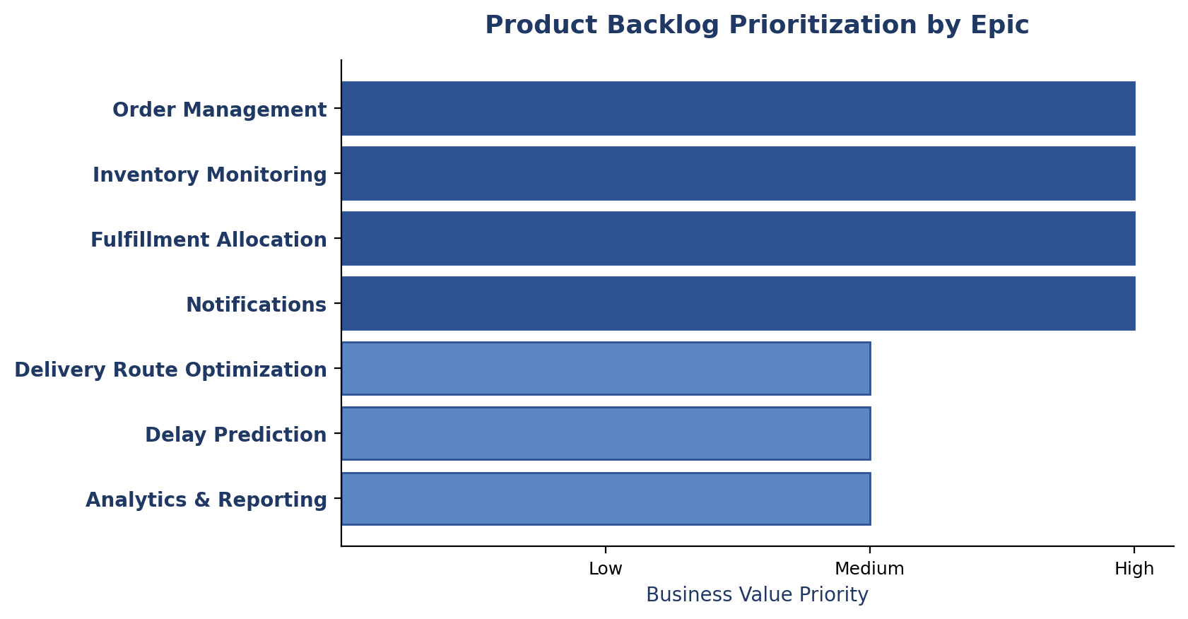
Fig 1: Product Backlog Prioritization by Epic
5. Sprint Backlog (Sprint 1)
The four highest-priority user stories are selected for Sprint 1, forming the core order-to-fulfillment pipeline. Each story is broken down into actionable development tasks below.
Selected User Story | Development Tasks
Place order online (US-1) | Design order schema; build checkout API; integrate payment gateway; generate order confirmation.
Real-time stock tracking (US-2) | Design inventory schema; build stock-update service; integrate with warehouse database; test sync accuracy.
Auto-assign fulfillment center (US-3) | Build fulfillment center database; implement allocation algorithm; integrate with order service; test allocation logic.
Order status notifications (US-4) | Integrate SMS/email gateway; build notification trigger service; design templates; test end-to-end flow.

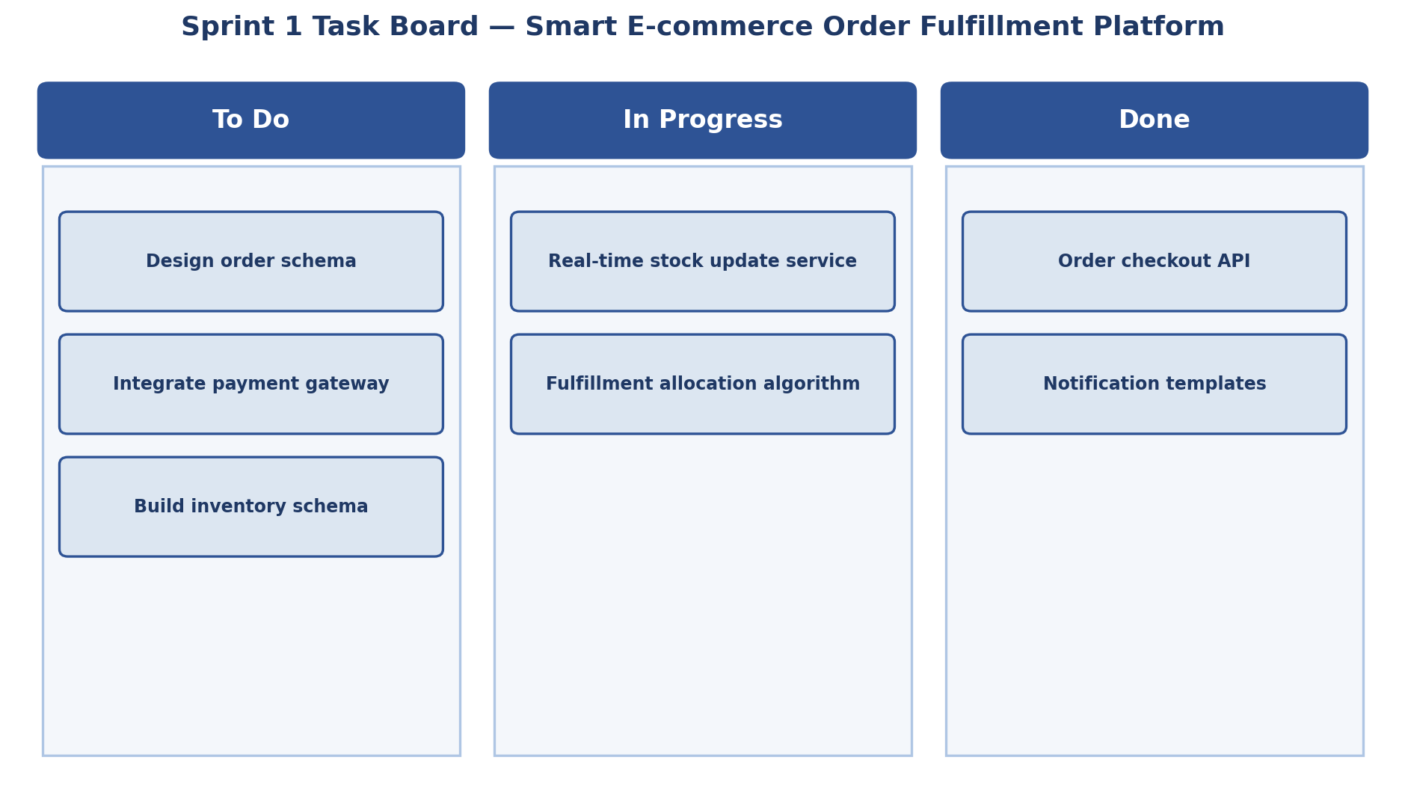
Fig 2: Sprint 1 Task Board

6. Story Point Estimation (Fibonacci Sequence)
User Story | Story Points | Justification
Place order online | 5 | Moderate complexity — checkout flow plus payment gateway integration.
Real-time stock tracking | 8 | High complexity — real-time synchronization across multiple warehouses.
Auto-assign fulfillment center | 8 | Requires an allocation algorithm combining location and stock data.
Order status notifications | 3 | Straightforward integration with existing SMS/email APIs.
Track order status (customer) | 3 | Simple read-only status display with low technical complexity.
Optimized delivery routes | 13 | Complex routing algorithm with multiple real-world constraints.
Delay prediction & alert | 8 | Requires integration with a predictive analytics model.

Sprint 1 total effort: 5 + 8 + 8 + 3 = 24 story points, based on the team's estimated velocity for a two-week sprint.
7. Sprint Goal and Expected Deliverables
Sprint Goal
Deliver a functioning core order-to-fulfillment pipeline by the end of Sprint 1 — enabling customers to place orders, warehouses to track real-time stock, orders to be automatically routed to the nearest fulfillment center, and customers to receive status notifications.
Expected Deliverables
- A functional order placement and checkout flow.
- A real-time inventory tracking module.
- An automated fulfillment center allocation engine.
- A customer notification system for order status updates.
- A demo-ready product increment integrating all four modules.
Code of Conduct:
I D. Nikhil Reddy - 192325045 (Name / Reg No) certify that this submission is my original work and that I have adhered to the guidelines specified for this assessment. I understand that any violation of academic integrity rules will result in disciplinary action.
Signature of the student:
D. Nikhil Reddy

